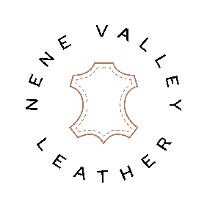

NENE VALLEY LEATHER RETURNS POLICY
Returns
Nene Valley Leather offers free UK returns.
Goods may be returned for exchange or refund within 30 days.
To start a return, contact us at: info@nenevalleyleather.com
If your return is accepted, we will arrange for courier collection. Ensure goods are packaged and accompanied by the original (or copy of) delivery note.
Items sent back to us without first requesting a return will not be accepted.
Leather which has been partially used, cut or otherwise damaged by the customer is non-refundable.

Damages And Issues
Outstanding orders can be cancelled at any time.
Please inspect your order upon receipt and contact us immediately if the item is defective, damaged or if you receive the wrong item, so that we can evaluate the issue and make it right.
We must be notified within 7 working days of receipt of goods supplied by us which have been damaged in transit or not matching goods ordered or described on the delivery note. Customers will be deemed to have accepted the goods as satisfactory if no such notification is received.
Nene Valley Leather is not liable for any loss caused by late delivery or failure to deliver by the company’s appointed delivery agent or carrier.

Overstock
At manager’s discretion we may accept return of overstocked, unused, original condition hides if advised within 60 days of original receipt.
Overstock returns will incur a 30% re-stocking fee and must be returned at buyers own cost. We don’t guarantee that we will receive your returned item.
For further information contact us at: info@nenevalleyleather.com

Refunds
Once your return is received, inspected and accepted, we will email to notify you that we have received your returned item/s. We will also notify you of the approval or rejection of your refund. If you are approved, then your refund will be processed, and a credit will be applied to your account or original method of payment within 30 days.

